26.51: Let 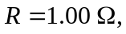the resistance of one wire. Each half of the wire has 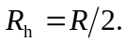
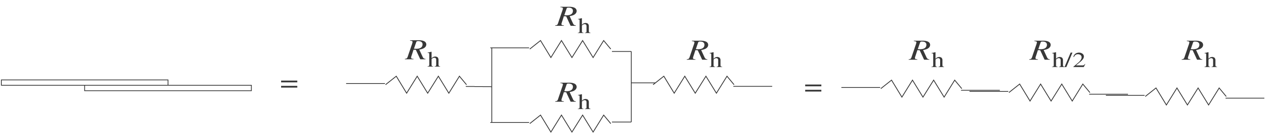
The equivalent resistance is

